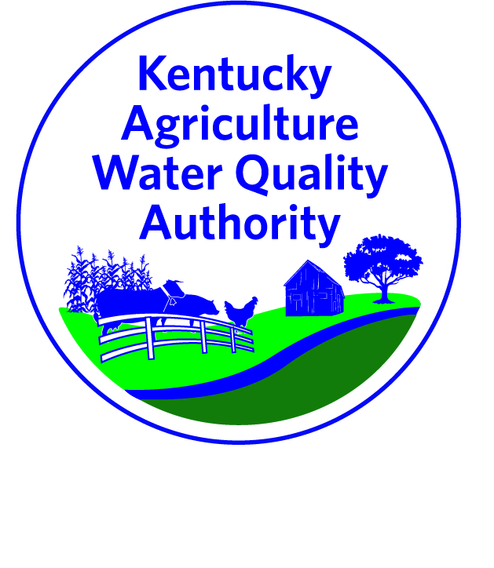
Established in 1994 to protect surface and groundwater resources from pollutants as a result of agriculture and silviculture activities.
(KRS 224.71-100 thought 224.71-145)
AWQA Strategic Plan
2/18/16
Goal #1 |  | Increase Compliance with the AWQA
OBJECTIVES |  | TASKS |  | SUBTASK | TARGET DATE | FINDINGS/ACCOMPLISHMENTS
1 | Continue and grow education and outreach efforts | - Develop AWQA brand for marketing (AWQA messaging) |  |  | 2017 | - Completed - New AWQA logo Spring 2016
 |  | - Develop tools for regionalized efforts
 |  | - Identify funding for long term staffing
 |  | - Investigate the addition of an AWQA question on the NASS |  | -Include Forestry data already collected from KDF | 2017 | - Completed - *Not feasible at this time due to cost Spring 2016
 |  | - Support development of staff so conservation district staff are able to assist in development of AWQA plans |  | -Collect and furnish data to regions where participation is historically low | 2017
 |  |  |  | -Provide additional training to district staff and supervisors | 2017 | - Completed - Training provided by Gumbert in March & Oct 2016
 |  |  |  | -Provide annual training for districts at KACD Convention | 2017 | - Completed - Training provided by Gumbert July 2016 & 2017
 |  | - Develop farmer support – develop a set of ads/photos/videos for promoting Ag Water Quality Act, BMPs featuring farmers |  |  | 2017 | - Completed - 3 videos produced Aug 2016 (B. James, M. Turner, J. Bednarski)
2 | Develop marketing tools including economic benefit. | - Determine prioritized list of BMPs for gathering economic data  ACTION: focus on 2-3 BMPs that will be heavily influential for promoting both water quality and economics, then promote the “brand” in order to sell the Authority
 |  | - Identify experts for assistance in accruing data
 |  | - Gather economic data
 |  | - Distribute economic data for use in presentations given by Authority members
 |  | - Establish an incentive for certification of AWQA plans
3 | Continue development of new BMP’s and include subject area experts for dissemination and adoption | - Obtain funding for research on MP effectiveness
 |  | - Conduct research on BMP effectiveness
 |  | - Develop public-private partnerships
 |  | - Outreach to KACD research committee
 |  | - Include education/training for Authority
Goal #2 |  | Improve Water Quality
OBJECTIVES |  | TASKS | SUBTASK |  | TARGET DATE | FINDINGS/ACCOMPLISHMENTS
1 | Build new and support existing ground & surface water monitoring efforts | - ACTION: Determine list of priority water quality parameters for trend monitoring
 |  | - ACTION: Determine what year may be appropriate for establishing trend baseline
 |  | - ACTION: Work with USGS to add additional Super Gages to the USGS network
 |  | - ACTION: Participate in the establishment of a soil moisture network
2 | Develop and support Ag Water Quality priority protection areas. | - Develop criteria for prioritization of areas
 |  | - Determine scale and number of priority areas
 |  | - Determine priority areas
 |  | - Share priorities with agencies to align funding priorities with priority areas
3 | Develop Regional AWQ Plans | - Determine what components are desired in a regional plan
 |  | - Review existing watershed plans for usage in a regional plan development
 |  | - Review existing priority areas for plan components (i.e. MRBI, NWQI NRS) | -Review Forest Action Plans
 |  | - Engage public in regional plans
 |  | - Conduct detailed monitoring including source identification
Goal #3 |  | Provide Adequate Funding for Implementation of the AWQA
OBJECTIVES |  | TASKS | SUBTASK |  | TARGET DATE | FINDINGS/ACCOMPLISHMENTS
1 | Work to further educate leaders about the Act and Authority. | - Conduct outreach to local governments & legislative leaders |  |  | 2017
 |  | - Develop PowerPoint slide and speaking points for Authority members to use in presentations |  |  | 2017 | - Completed - PowerPoint developed and available for use (Dec 2016)
 |  | - Convene a workgroup of stakeholders to discuss approaches to increasing funding for the implementation of the Agriculture Water Quality Act. | - ACTION: what is the $ needed for? Staff (Coordinator)? Marketing? |  | 2017
2 | Raise awareness of the importance of financial assistance | - Develop briefing sheet on AWQA |  |  | 2017 | - Completed - Briefing sheet developed and available for use (Sept 2016)
 |  | - Share priorities of funding to align funding with priority areas Funding priorities: staff, marketing, branding
Goal #4 |  | Maintain a Highly Functional AWQ Authority
OBJECTIVES |  | TASKS | SUBTASK |  | TARGET DATE | FINDINGS/ACCOMPLISHMENTS
1 | Formalize procedures | - Adopt business rules |  |  | 2017
 |  | - Develop annual report |  |  | 2017
 |  | - Determine committee rules and functions |  |  | 2017 | - Completed - Formalized and inserted in committee notebooks (spring 2016)
 |  | - Clarify process for BMP revisions (timelines/who/how) |  |  | 2017 | - Completed - Process and timelines clarified & inserted in committee notebooks (spring 2016)
2 | Further integrate the Soil and Water Conservation Commission | - Conduct an annual joint meeting of Authority and Commission
 |  | - Conduct training annually for new Commissioners and Supervisors
 |  | - Work with Commission to develop positive motivators for state cost share funds in conjunction with AWQA plans
3 | Objective – Research options for updating pieces of the AWQ Act itself vs. development of Regulations based on the existing statute ACTION: Establish a work group for further discussion
4 | Increase active review of BMPs by AWQA members | - AWQA members will conduct on-site reviews of functioning BMPs annually
 |  | - AWQA members will complete annual report of successes and barriers

